**VPC Peering (19th Sep 2024)**

1. **Create Two VPC**

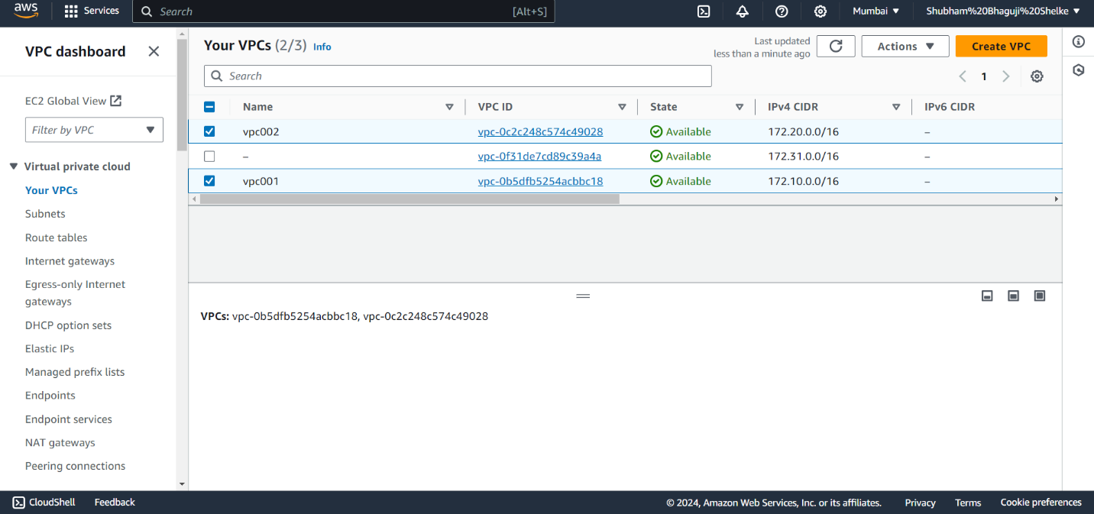

1. **Create two subnets in VPC001**

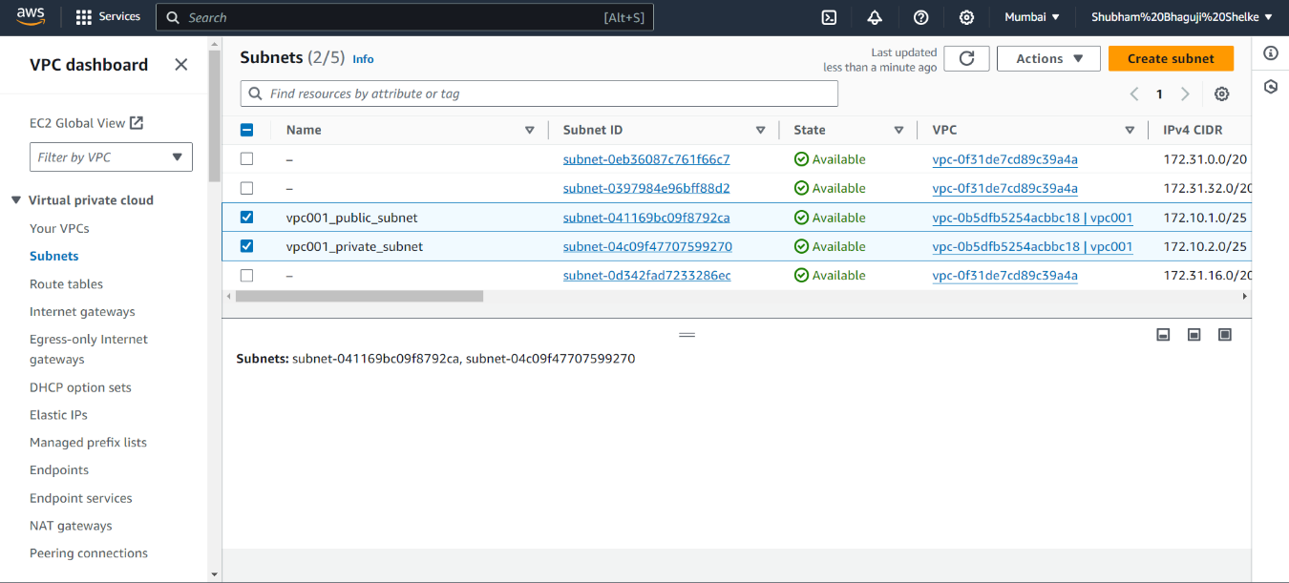

1. **Create two subnets in VPC002**

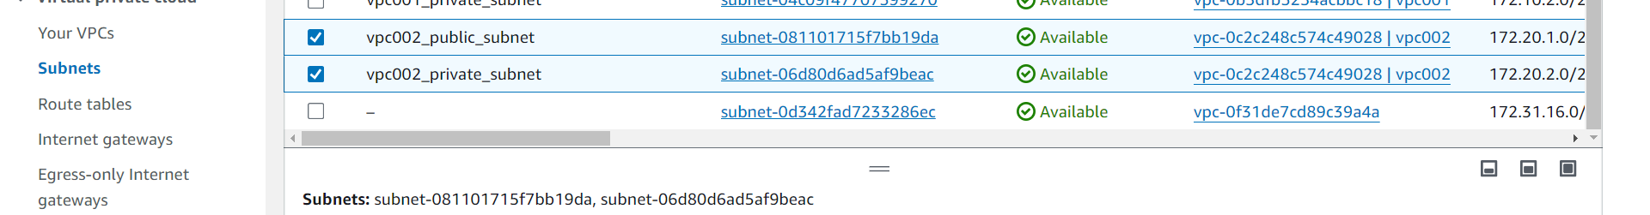

1. **Create internet gateway “IGW_VPC001” and attached to VPC001**

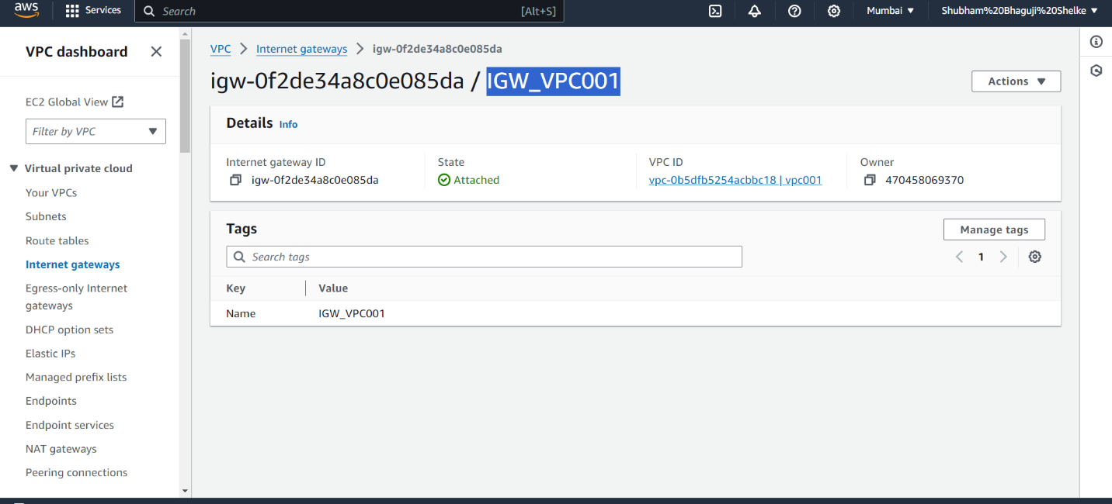

1. **Create internet gateway “IGW_VPC002” and attached to VPC002**

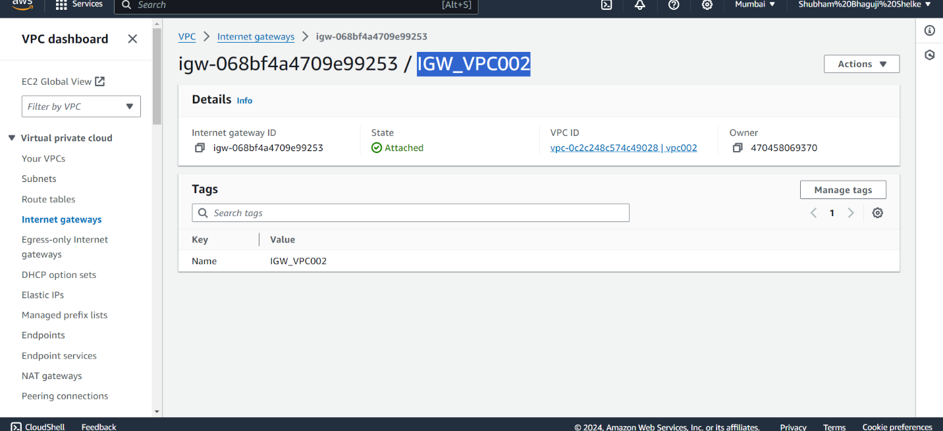

1. **Enable to Auto-Assign setting for both public setting**

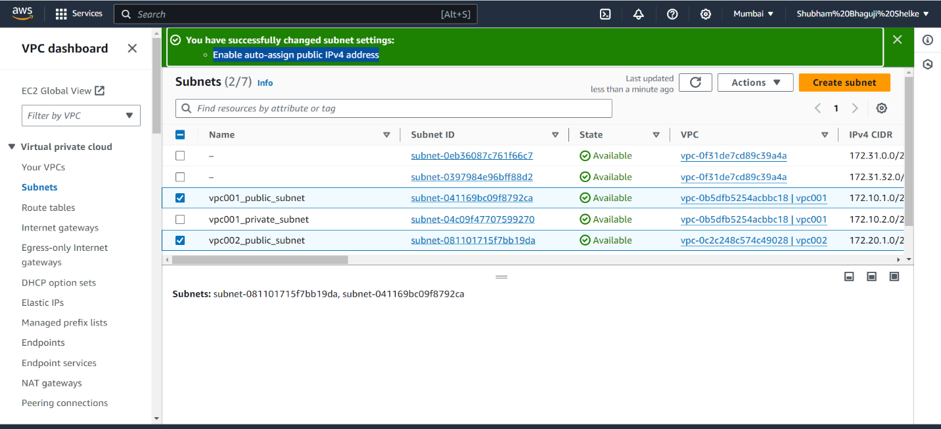

1. **Create Route Table in VPC001**

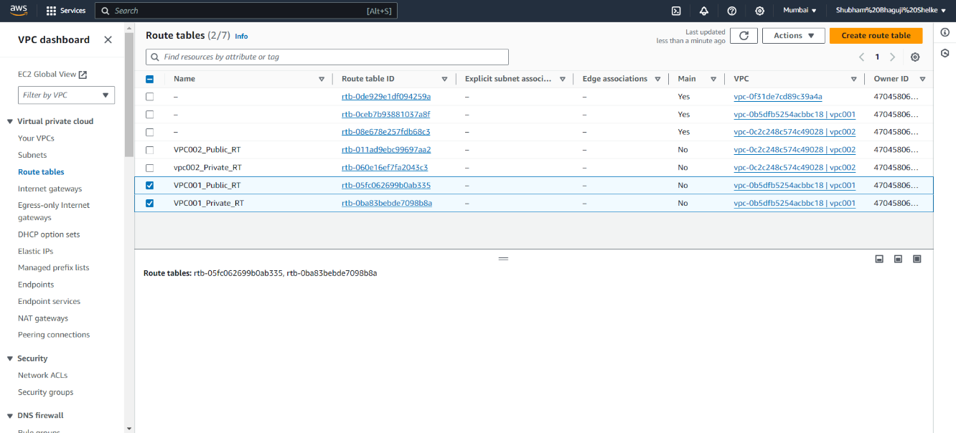

1. **Create Route Table in VPC002**

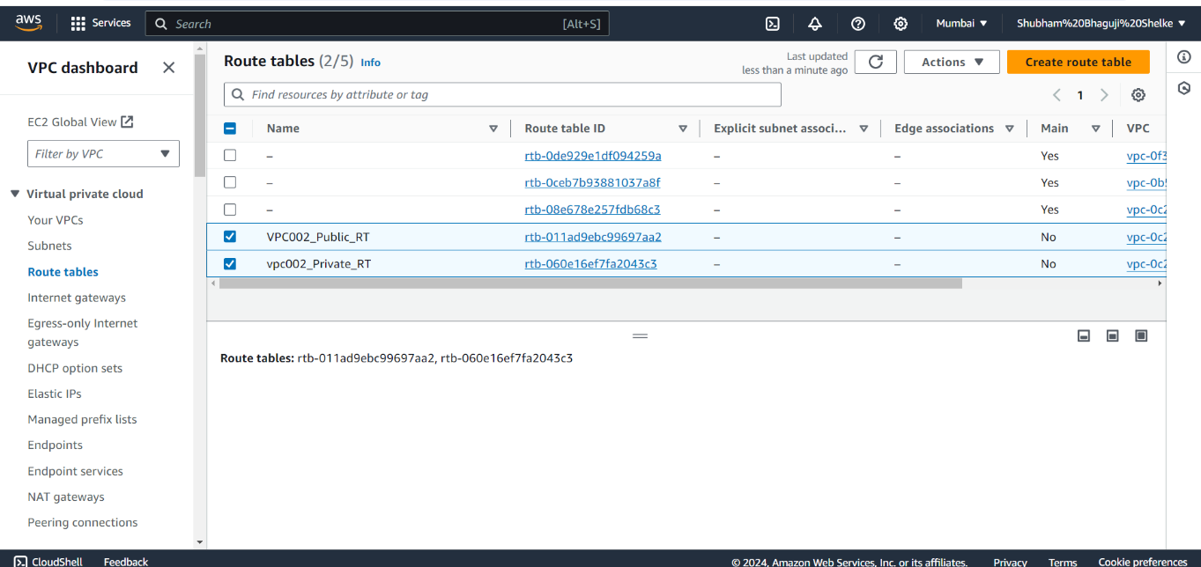

1. **Create Two NAT Gateway for “VPC001” & “VPC002”**

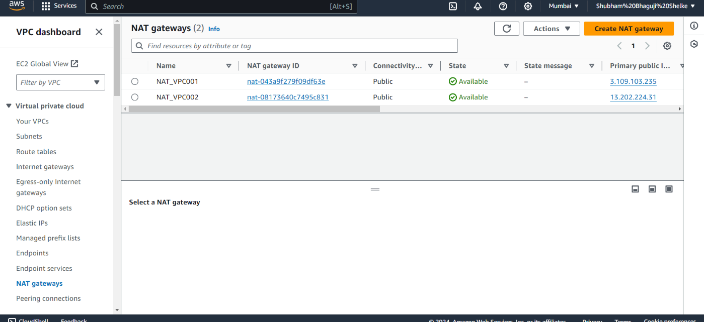

1. **Route Table Setting**
2. VPC001_Public_RT – Edit Route – Add Route – Assign 0.0.0.0/0 IP and Select Internet Gateway (IGW_VPC001)

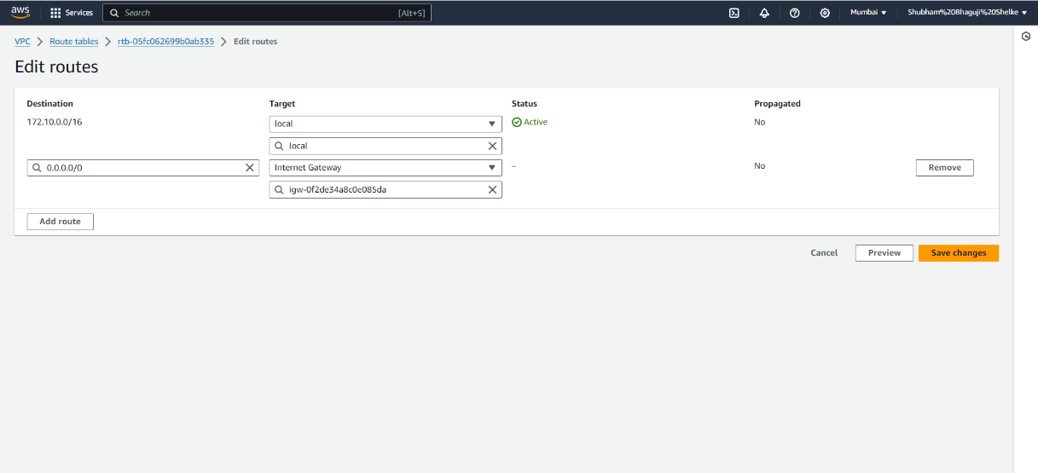

1. VPC001_Public_RT – Subnet Association – Select VPC001_Public_Subnet

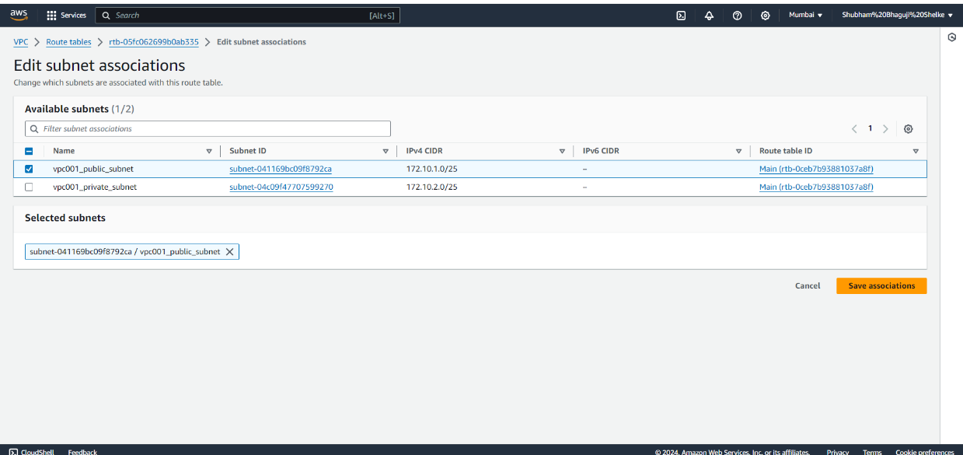

1. VPC002_Public_RT – Edit Route – Add Route – assign 0.0.0.0/0 IP and Select Internet Gateway (IGW_VPC002)

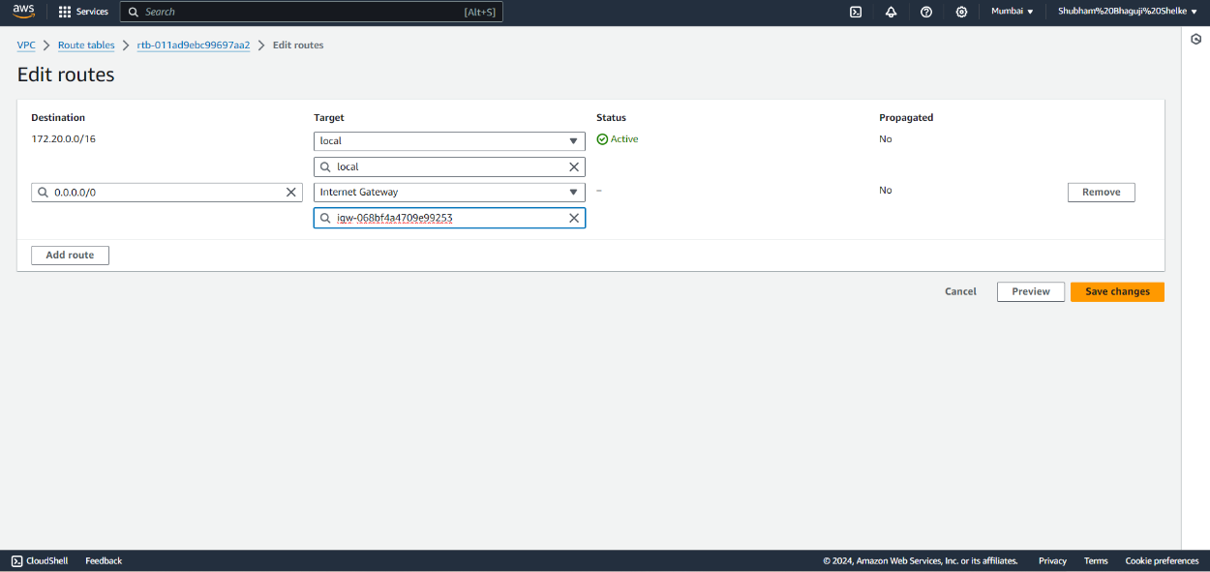

1. VPC002_Public_RT – Subnet Association – Select VPC002_Public_Subnet

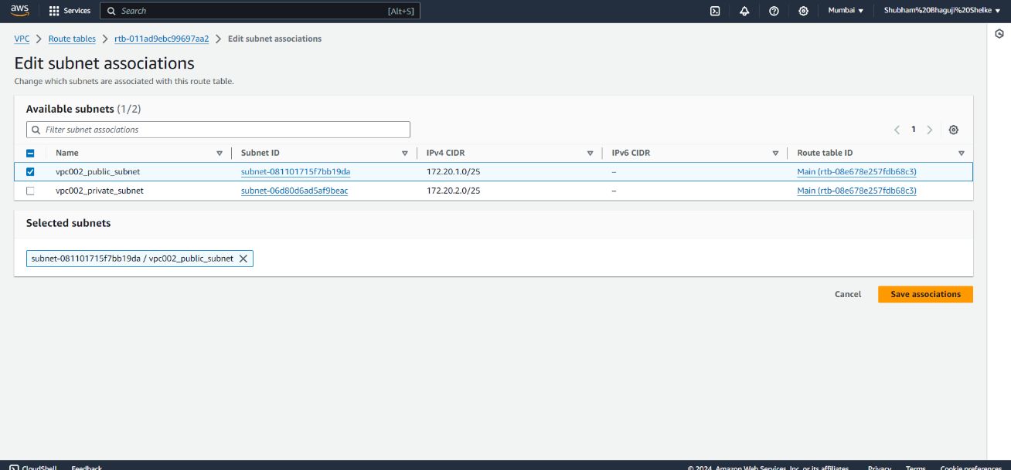

1. VPC001_Private_RT – Edit Route – Add Route – assign 0.0.0.0/0 IP Select NAT Gateway (NAT_VPC001)

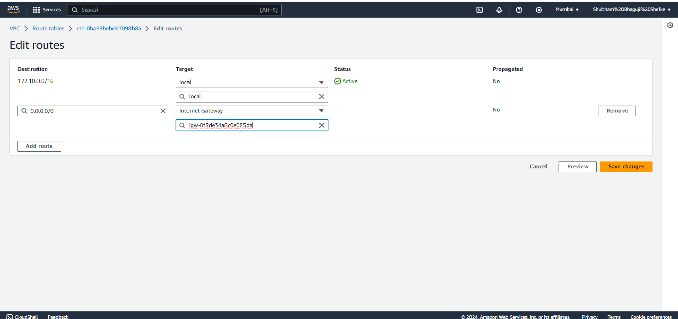

1. VPC001_Private_RT – Subnet Association – Select VPC001_Private_Subnet

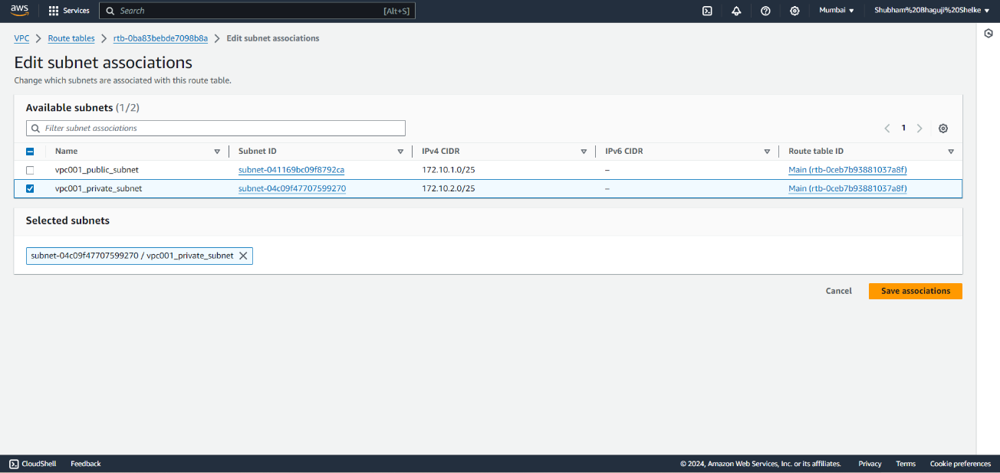

1. VPC002_Private_RT – Edit Route – Add Route – assign 0.0.0.0/0 IP and Select NAT Gateway (NAT_VPC002)

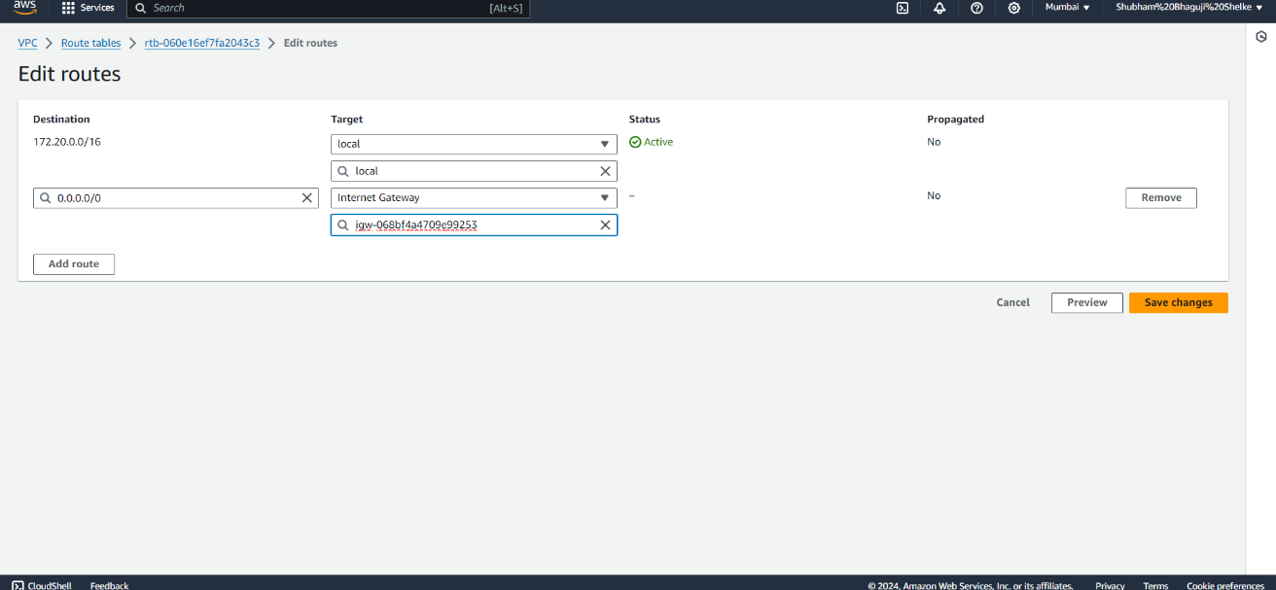

1. VPC002_Private_RT – Subnet Association – Select VPC002_Private_Subnet

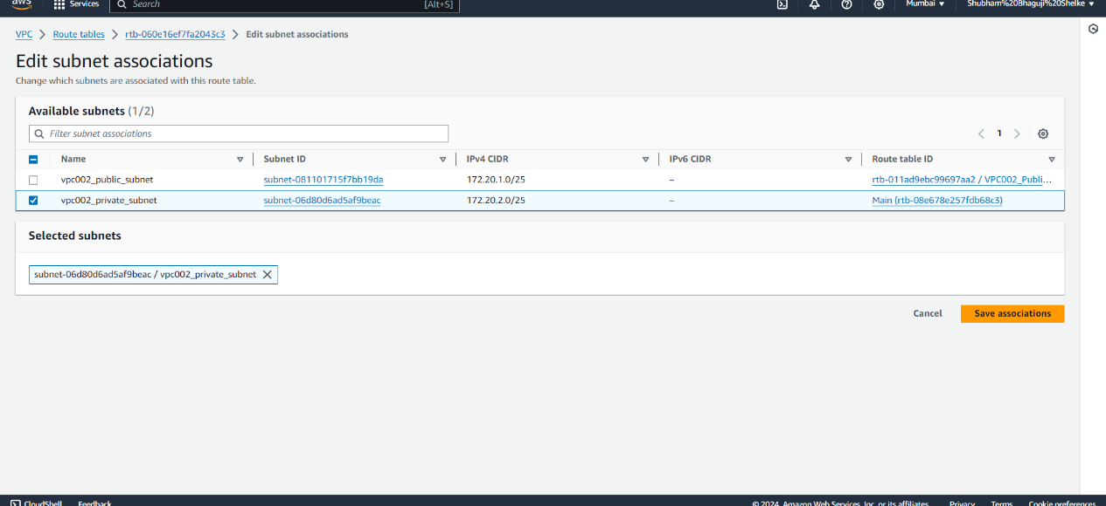

1. **Create Peering connection between “VPC001” and “VPC002”**

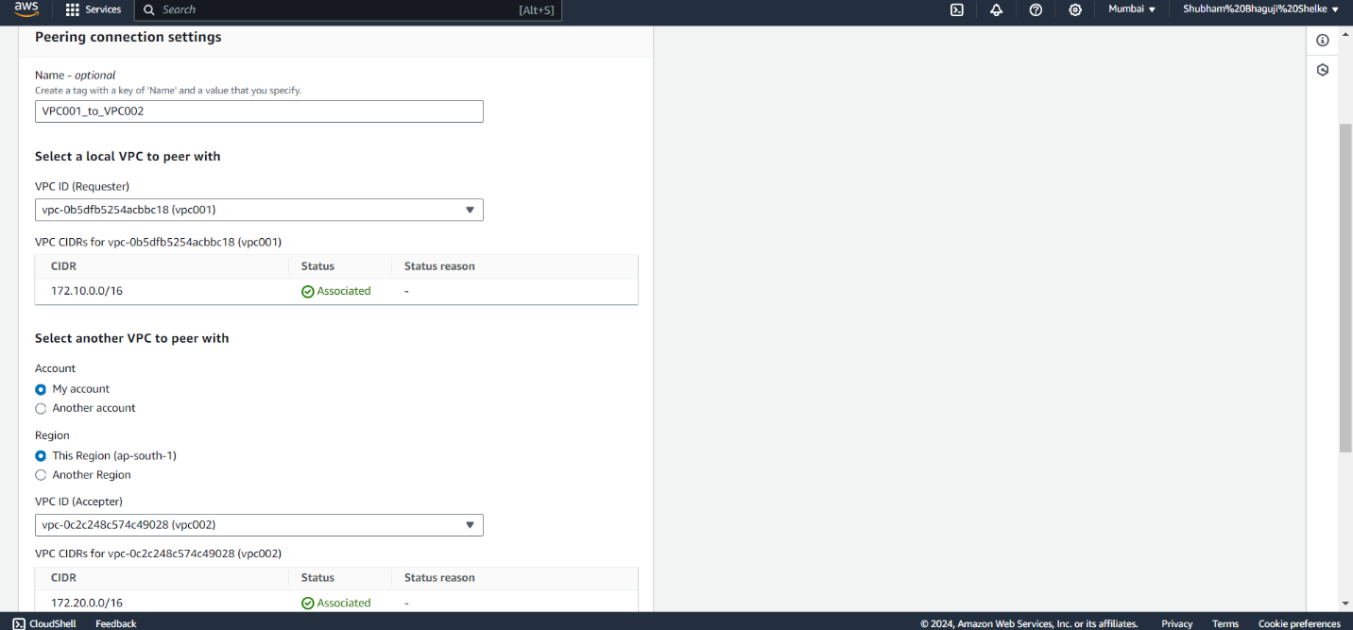

1. **Peering connection is in Pending State , i.e., yet to accept request from VPC002**

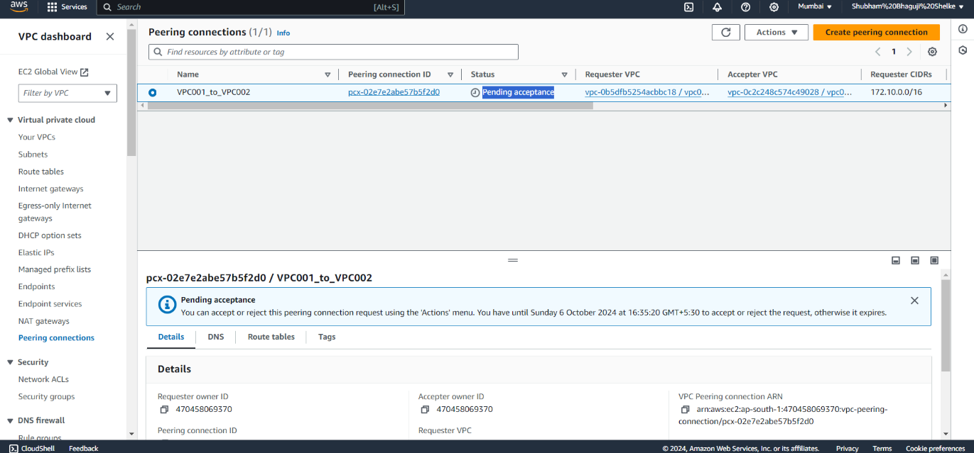

1. **After accepting request it should change state to in “Active”**

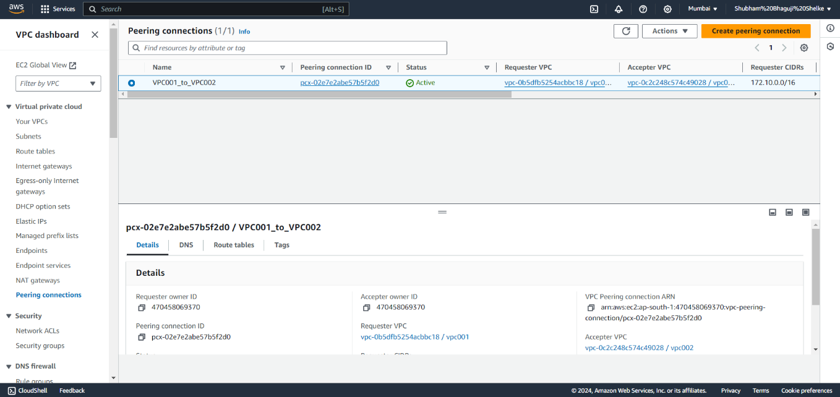

1. **Modify Route Tables**
2. Change VPC001_Public_RT Route Setting – Add Route – enter IP of VPC002 and select peering connection (VPC001_to_VPC002)
3. Change VPC002_Private_RT Route Setting – Add Route – enter IP of VPCOO1 and select peering connection (VPC001_to_VPC002)
4. **Create two instance VPC001_Public_Subnet VM and VPC002_Private_Subnet_VM**
5. **Connect VPC001_Public_Subnet_VM via putty**